**République de Côte d’Ivoire**

**Union – Discipline – Travail**

**Ministère de l’Enseignement**

**Supérieur et de la Recherche Scientifique**





**CEFIVE**

**MEMOIR DE FIN DE CYCLE**

**Pour l’obtention du diplôme d’ingénieur des Techniques Informatiques**

* ***Option : Système de Gestion des Bases de Données, Génie Logiciel et Applications Métiers***

**ETUDE ET MISE EN PLACE D’UNE PLATEFORME POUR LA GESTION ADMINISTRATIVE DU PERSONNEL DE LA DIRECTION GENERALE DES MARCHES PUBLICS (DGMP)**

**Maître de stage:**

**M. DJAN DJAN OLIVIER**

Réalisé par : **COULIBALY LENIMAMAN IBRAHIMA, Elève Ingénieur des Techniques Informatiques au CEFIVE**

**Maître de stage:**

**M. DJAN DJAN OLIVIER**

# DEDICACES

**Directeur de projet :**

**M. AFFIAN ROGER, Directeur des Etudes au CEFIVE**

**Maître de stage :**

**M. DJAN OLIVIER, Chef de Service à la DGMP**

A ma famille

# THANKS

I would like to thank the General Director of Public Markets, Mr. Youl Sansan François, for the traineeship he offered me as well as for the opportunity that I had to carry out this training in evening classes while being in exercise in the structure he directs.

I also call on the Deputy Director of Studies, Monitoring and Evaluation of Public Markets, Mr. Kpagni Pierre for his support, his wise advice and above all for the facilities I was able to benefit from related to the hours of descent in order to be able to follow my courses.

I will not miss to say thanks to the Head of the General Means and Personnel Department, Mr. Yao Constant and his collaborators for the valuable information they provided to me as well as for their good collaboration in the success of this project.

My thanks also go to the Deputy Director of Information and Communication Systems, Mr. Bocoum Amadou, as well as to his entire team for the technical supervision

Many thanks to my internship supervisor Mr. Djan Olivier for the follow-up and the professional supervision that I received from him.

I also thank the Director of Studies of CEFIVE, Mr. AFFIAN Roger for his great concern as well as the technical and pedagogical supervision he has shown to me.

My thanks go particularly to my big brother and unfailing mentor, Soro Nimbéléfia Amadou for proofreading, corrections and advice on use. Above all, I will not forget to say thank to him for all the benefits that I cannot finish mentioning in this memoir.

I extend my deepest gratitude to my wife for her emotional and moral support, as well as for her encouragement.

My sincere thanks go especially to my Father and my Mother for all the sacrifices they never failed to consent for me as well as for the blessings with which they accompany me in all my undertakings.

I will never miss the opportunity to reward all my family members for their unconditional support at all levels.

I also thank all the people whom I have not mentioned here, who from near or far grant me their precious support.

# SOMMAIRE

Table des matières

[DEDICACES 1](#_Toc111140369)

[THANKS 3](#_Toc111140370)

[SOMMAIRE 4](#_Toc111140371)

[SUMARY 6](#_Toc111140372)

[INTRODUCTION 7](#_Toc111140373)

[PART I : FRAMEWORK 8](#_Toc111140374)

[1.1 Study of the existing 9](#_Toc111140375)

[Description of the existing 9](#_Toc111140376)

[1.2 Reviews, Problems and Solutions 9](#_Toc111140377)

[1.2.1 Reviews of the existing 9](#_Toc111140379)

[1.2.2 Problems 10](#_Toc111140380)

[1.2.3 Solutions 10](#_Toc111140381)

[1.3 Cahier des charges et choix de la solution 10](#_Toc111140382)

[1.3.1 Cahier des charges 10](#_Toc111140384)

[1.3.2 Choice of the solution 11](#_Toc111140385)

[PART II: STUDY OF THE SOLUTION 12](#_Toc111140386)

[2.1 Etude conceptuelle 13](#_Toc111140389)

[2.1.1 Context Diagram / Identification of the actors 13](#_Toc111140390)

[2.1.2 Use cases Diagram 13](#_Toc111140391)

[2.1.3 Diagrammes des classes 14](#_Toc111140392)

[2.1.4 Diagrammes de séquence 15](#_Toc111140393)

[3.1.1 Traitement des demandes d’actes administratifs 19](#_Toc111140394)

[3.2 Etude technique 19](#_Toc111140395)

[3.2.1 Architectures 19](#_Toc111140396)

[3.2.2 Technologies de développement 20](#_Toc111140397)

[PARTIE III : REALISATION DE LA SOLUTION 21](#_Toc111140398)

[3.1 Development 22](#_Toc111140399)

[3.1.1 Frontend development 22](#_Toc111140400)

[3.1.2 Backend development 24](#_Toc111140401)

[3.2 Putting into operation 25](#_Toc111140402)

[3.2.1 Deployment Environments 25](#_Toc111140403)

[1. SOLUTION COST 25](#_Toc111140404)

[CONCLUSION 26](#_Toc111140405)

[BIBLIOGRAPHIC REFERENCES 27](#_Toc111140406)

[WEBOGRAPHIE 27](#_Toc111140407)

[TABLE OF CONTENTS 28](#_Toc111140408)

# SUMARY

Personnel management is a very important function in the functioning of an administration. The implementation of this function raises important challenges to be met. These challenges concern both efficiency and speed in the processing of files and the security of personnel data. Thus, without necessarily being the production activity of a structure, personnel management can prove to be very costly in terms of time, material, financial and human resources if we do not have adequate means. Therefore, to be carried out successfully, it is necessary to have tools allowing on the one hand to save resources and on the other hand to ensure the security and quality of the information handled.

This issue still available for the General Direction of the Public Markets (DGMP), whose personnel management system is essentially based on physical (paper) archiving of documents.

This thesis aims to provide a solution to this problem faced by the DGMP. To do this, we opted, after analysing and studying several solutions, for the implementation of a web application, to automate the management of personnel.

The implementation of this solution has two main aspects which are the frontend development which concerns the graphical interface and the backend development which concerns the functionalities at work in the background. The technologies used are respectively the React JS library for the front part and the Spring Boot Framework for the back part.

The architecture of the system is an event-driven microservice architecture (Event Driven Microservices).

The database management system used is PostGres SQL.

In addition to the deployment, we opted for the establishment of three environments which are the development, test and production environments.

Finally, the cost of the project calculated with the cocomo method is estimated at 40 million CFA francs.

# INTRODUCTION

The administrative management of personnel can quickly become cumbersome and difficult to maintain without a suitable, efficient and effective system. In the digital age, the use of an automated personnel management system has indeed become essential for a department in charge of personnel. In fact, the administration faces today, increasingly growing challenges. Indeed, it must be able to adapt to technological changes in order to best meet the growing needs of the customers and meet the expectations of its workers. Thus, the administrative management of personnel, which constitutes an essential link for the survival of an administration, has a capital role to play. In essence, it must respond effectively to the need for speed in the day-to-day processing of cases and help in decision-making by making reliable statistics available to the manager in real time. It is to provide an answer to this problem that we have chosen to work on the theme Study and implementation of an automated personnel management platform as part of our end-of-cycle dissertation.

To do this, our document will be structured in three parts. The first part will address the frame of reference, the second will focus on the study of the chosen solution and the third will concern the realization of the chosen solution.

# PART I : FRAMEWORK

## Study of the existing

### Description of the existing

Personnel management activities within the General Directorate of Public Markets are carried out by the General Resources and Personnel Department. This service reports directly to the Director General of Public Procurement and is overseen by a head of service appointed by appointment decision signed by the Director General of Public Procurement. The latter is supplemented in his task by research officers.

To carry out its mission, the service has an office equipped with a cupboard for storing files, standard office equipment (printer, punch, photocopier, etc.) and office computers at the rate of one computer per person. These computers are equipped with Word and Excel office software from the Microsoft Office suite. It is also mainly with the help of these two software that the service performs most of its tasks. In this case, the Head of Department keeps a list of staff on his computer in an Excel workbook that he updates according to the arrival and departure movements of agents within the DGMP. His collaborators also have several Word files scattered on their computers. These files serve as basic templates for writing the various letters they process on a routine basis.

In addition, there is a massive and almost indispensable presence of the mail service in the operation of the General Resources and Personnel Service. This preponderance is justified by the need to be able to route the files processed to remote targets within the DGMP and outside.

## Reviews, Problems and Solutions



### Reviews of the existing

In view of the above, the personnel management system of the Directorate-General for Public Procurement is essentially based on physical (paper) archiving of documents, increased use of Word and Excel software from the Microsoft Office suite and an almost indispensable presence of the mail service for the transmission of information to various targets.

This method of operation has the advantage of working because it is how the department has always functioned for many years. It also has the merit of always leaving a written record of all actions carried out in the context of personnel management. It should also be noted that the use of model letters in the drafting of current files facilitates the processing of certain files while avoiding the desk officer having to reinvent the wheel every time he or she needs to process a file. In addition, the use of an Excel workbook for the staff list has the advantage of making it easier to consult and update staff information. On the other hand, although the current method of personnel management has some advantages, it nevertheless has some important shortcomings that need to be corrected. These handicaps are mainly the following:

* Inefficiency in handling routine cases;
* The unreliability of the data from the staff list;
* Lack of security of the file system (Word and Excel) used for personnel management;
* The difficulty of producing reliable statistics in real time;

### Problems

i. How can the DGMP's personnel management system be made efficient?

ii. How to make the data from the DGMP's personnel management system reliable?

iii. How to secure the data on personnel?

iv. How to produce reliable statistics on personnel in real time?

To answer these questions, we will study three (3) proposed solutions.

### Solutions

We found out three possible solutions to solve this problem:

* ERP for (Enterprise Resource Planning);
* Login to a SaaS (Service as a Software);
* Develop our own software;

## Cahier des charges et choix de la solution



### Cahier des charges

#### The theme

THEME: Etude et mise en place d’une plateforme automatisée de gestion du personnel : cas de la Direction Générale des Marchés Publics

#### Spécifications fonctionnelles

Les fonctionnalités de la gestion du personnel prises en compte par le projet sont les suivantes :

* **La gestion des agents** (Informations sur le personnel)
* **La gestion des mouvements** prenant en compte les entrées, les mouvements internes (affectations), les départs volontaires, la disponibilité, les retraites, les décès.
* **La gestion des Carrières** prenant en compte les promotions, les nominations, les avancements et la mobilité professionnelle ;
* **La gestion des absences** prenant en compte les autorisations d’absence, les congés annuels, les repos maladies, les congés de maternité et les absences injustifiées ;
* **La gestion des archives** prenant en compte les actes de nomination, de promotion, d’avancement, les pièces d’identités, les actes de naissance, de mariage, de décès, … ;
* **La gestion des demandes** qui prend en compte le suivi et le traitement des demandes d’acte (Certificat de travail, Attestation de présence au post), les demande d’absence, les demandes de mouvements et les besoins en personnel ;
* **Un tableau de bord statistique** donnant une vue d’ensemble sur les fonctions précitées.

NB : This project does not implement the payment functionality which is a feature already managed by the Payroll Directorate (Direction de la Solde)

### Choice of the solution

The following bord presents the score given to each of the three solutions listed above. To do that, we picked out six (6) criteria weighted according to their relative importance. The determination of these criteria and their weighting coefficients was made on the basis of a survey realised among the business actors (personnel of the service in charge of personnel management), the developers and the future users of the system. These criteria are as follows: cost, delivery time, ease of integration of the solution, exclusive holding of data by the DGMP, consumption of internal resources, high availability. For each of these criteria, a score is assigned to each solution on a scale ranging from 1 to 5. The overall score for each solution is obtained by summing the scores obtained on each criterion weighted by the weight of the criterion.

Thus, based on this principle, the “internal application” solution appears to be the most appropriate with an overall score of 390 against 290 for ERP and 250 for SAAS. Therefore, to respond to the problem posed, we have chosen to develop in-house a web application which will expose, through various graphical interfaces, the main functions of the administrative management of the personnel. This application will be based on a database that will store and secure personnel data. This application will have a "Dashboard" module which will present the statistics relating to the personnel.



# PART II: STUDY OF THE SOLUTION



## Conceptual study

### Context Diagram / Identification of the actors

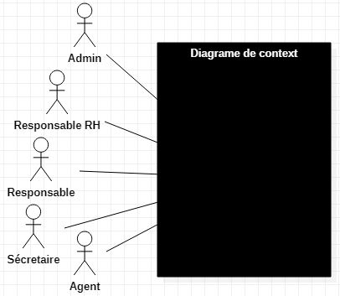

### Use cases Diagram

**Use Cases diagrams** are UML diagrams used to give an overall view of the functional behavior of a system. A use case represents a unit of interaction between a user (human or machine) and a system. In a use case diagram, users are called actors, and they interact with the use cases.

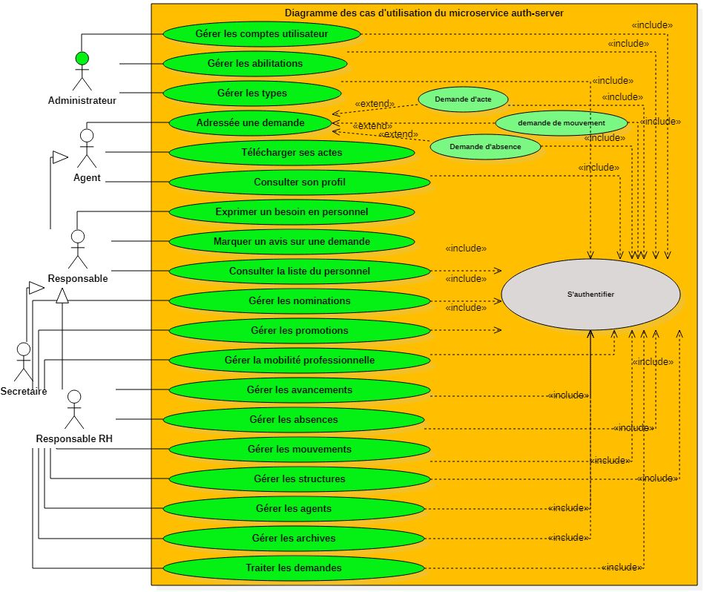

### Classes diagrams

A class is a set of functions and data (attributes) that are linked together by a semantic field. Classes are used in object-oriented programming. They allow to model a program and thus to break down a complex task into several small simple tasks.

The class diagram is a diagram used in software engineering to present the classes and interfaces of systems and the different relationships between them. This diagram is part of the static part of UML because it abstracts from temporal and dynamic aspects.Diagramme de classe du Système de Gestion du Personnel de la DGMP

**Diagramme de classes du système** 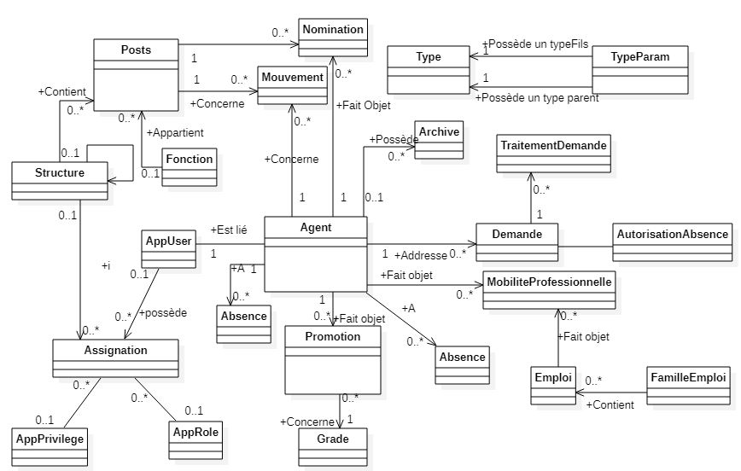

**NB : Dans ce diagramme, nous mettons l’accent sur les liaisons sémantiques entre les classes. Ainsi, nous avons, expressément omis les attributs des classes en vue de rendre facile la lecture du diagramme.**

### Sequence diagrams

Les diagrammes de séquences permettent de décrire comment les éléments du système interagissent entre eux et avec les acteurs. Ils sont une solution populaire de modélisation dynamique en langage UML, car ils se concentrent plus précisément sur les lignes de vie*,* les processus et les objets qui vivent simultanément, et les messages qu'ils échangent entre eux pour exercer une fonction avant la fin de la ligne de vie.

#### D:\INFORMATIQUE\Cours\CEFIVE\Projet-Prof\CEFIVE-Rapport-ProjetProf\Rapport stage\models\staffadmin_authentication_sequence_dgrm2.JPGDiagramme de séquence « Authentification »

* **Commentaires**

**1** : L’acteur saisi ses données d’authentification dans le formulaire d’authentification à partir d’un navigateur web.

**2** : Il clique sur le bouton valider du formulaire, ce qui déclenche la soumission du formulaire.

**3**: La soumission du formulaire déclenche une requête http vers le serveur d’application

**4** : Le serveur d’application procède à la vérification du login et du mot de passe saisie par l’acteur.

**5** : Si les données d’authentification sont correctes, le serveur d’application retourne la page d’accueil à l’écran du navigateur.

**6** : Si les données d’authentification ne pas correctes, le serveur d’application retourne la page d’authentification au navigateur.

Le processus d’authentification ainsi décrit, sera requis pour toutes les actions à réaliser à travers le système. Cela dit, dans les diagrammes de séquence que nous présenterons par la suite, nous nous limiterons à faire référence à ce diagramme d’authentification, sans toutefois le représenter entièrement, afin de ne pas surcharger la présentation. Toutefois, toujours dans le souci de ne pas surcharger les diagrammes, nous omettrons sciemment, dans certains cas, de faire référence à ce diagramme d’authentification.

#### Diagramme de séquence « Recrutement »

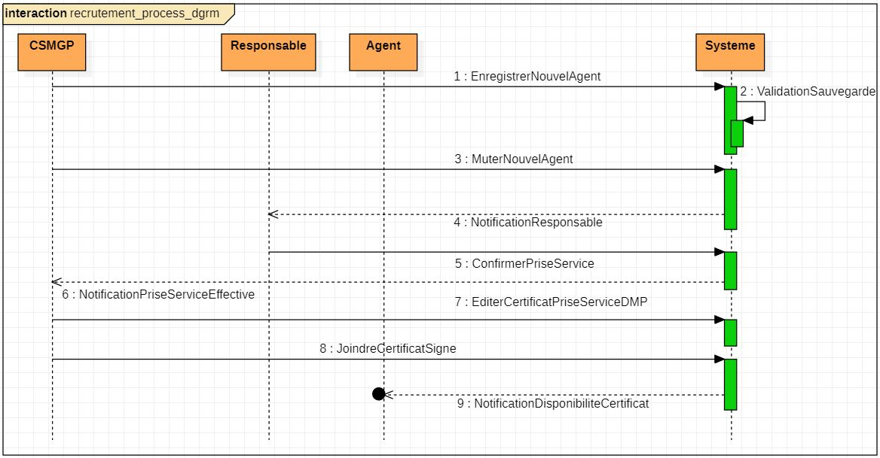

**Diagramme de séquence du processus de recrutement**

* **Commentaires :**

**1 :** Le Responsable RH enregistre les données d’un nouvel agent dans le système

**2 :** Le système vérifie et valide les informations saisies avant de les sauvegarder

**3 :** Le Responsable RH procède à la mutation du nouvel agent au sein d’un service de la DGMP

4 : Le système notifie le responsable de ce service de l’affectation d’un nouvel agent au sein de l’un de ses services

**5 :** Le responsable du service confirme la prise de service du nouvel agent (après que l’agent ait effectivement pris service)

**6 :** Le système notifie le Responsable RH de la prise de service effective du nouvel agent

**7 :** Le Responsable RH édite le certificat de prise de service du nouvel agent

**8 :** Le Responsable RH joint le certificat de prise de service signé par le DGMP au dossier de l’agent

**9 :** Le système notifie l’agent de la disponibilité de son certificat de prise de service.

## Technical study

### Architectures

Many applications operate on a client/server communication model, which means that client machines contact a server, a machine that is usually very powerful in terms of input/output capabilities, which provides them services. These services are programs that provide data such as time, files, connection, etc. There are several architectures based on this mode of operation (2-tier architecture, 3-tier architecture, microservices architecture, etc.). In this project, we have chosen to use the microservices architecture to build the system.

### Development Technologies

Technically, the development of web applications consists of writing several lines of code that are executed by several servers in order to generate web pages. These pages are then transmitted to browsers which interpret them in order to produce the graphic display elements (images, colours, tables, forms, etc.). That said, development activities are quite tedious and time-consuming. Therefore, it is essential to use wizards to reduce the amount of code required and optimise the development process. These wizards can be frameworks, libraries or libraries. In the context of this project, the technologies we will use can be classified into three categories: frontend technologies, backend technologies and database technologies. The figure below presents all these technologies.

**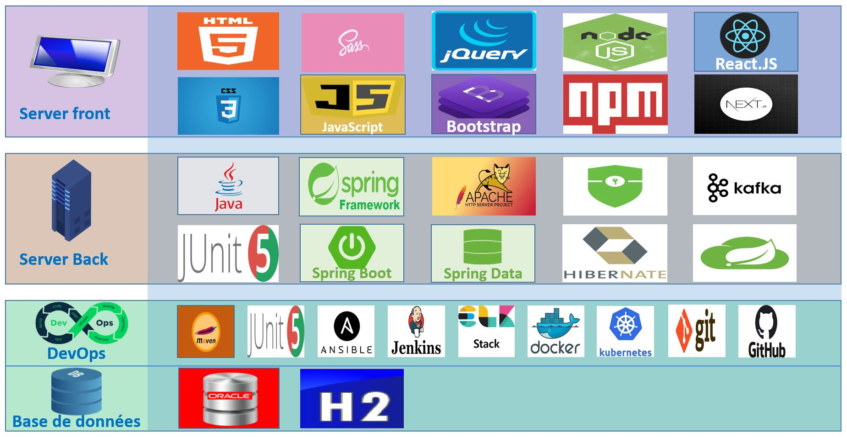**

# PARTIE III : REALISATION DE LA SOLUTION

## Development

### Frontend development

#### Template choice

A Template is a "prefabricated" site model. It is designed to be easily adapted and integrated into different scenarios.

For this project, we have chosen to use the AdminLTE v3.2.0 Template available for free download from https://www.adminlte.io

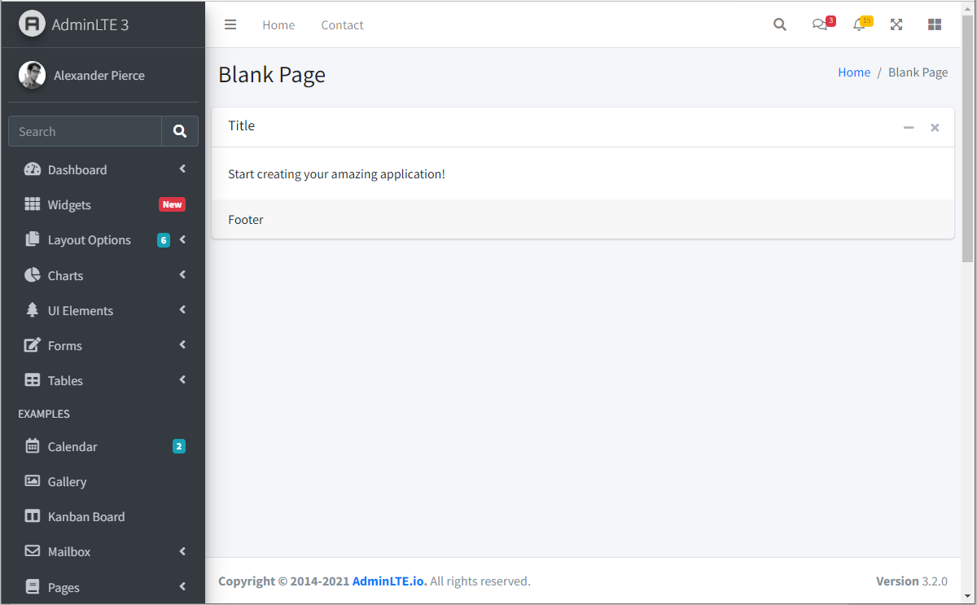

Template

#### Modules and pages identification

|  |  |  |
| --- | --- | --- |
| Modules | Pages | Functionalities |
| Gestion des comptes et droits d’accès | Login | * + Authenticate |
| Users accounts management | - Consult the list of users (table);  - Create a user account (modal window);  - Modify a user (modal window);  - Consult the details of a user (modal window);  - Assign / revoke a privilege to a user;  - Assign / revoke a role to a user;  - Activate or deactivate a user account; |
| New accounts activation | * + Activate account from an activation link |
| Access management | * + Consult the list of roles and privileges   + Create a role or a privilege;   + Modify a role or a privilege;   + Assign/revoke a privilege to a role;   + Assign/revoke a role to a user;   + Assign/revoke a privilege to user; |
| Personnel management | List of personnel | - Consult the list of personnel;  - Register a new agent;  - Modify an agent  - Assign an agent to a structure;  - Appoint an agent to a position of responsibility;  - Register a promotion for an agent; |
| Personnel details | - View the details of an agent;  - Modify an agent;  - Assign an agent to a structure;  - Appoint an agent to a position of responsibility;  - Register a promotion for an agent;  - View an agent's list of requests;  Consult the history of events on an agent (movements, promotion, appointment, absences, etc.); |
| Structures management | List of the structures | - Consult the list of structures;  - Create a new structure;  - Modify a structure;  Assign an agent to a structure; |
| Structure Details | - View the details of a structure;  - See the list of agents belonging to a structure;  - See the list of structures under supervision;  - See the information on the manager of a structure;  - Modify a structure;  Assign one or more agents to a structure; |
| Movements management | List of movements | - See the list of movements by type (Arrival, Assignment, Retirement, Death, Voluntary departure, ...);  - Register a new movement;  - Modify a movement;  - Search for movements according to different criteria; |
| Demands management | List of demands | - Consult the list of demands;  - See the details of a demands;  - Make a new demand;  - Modify a demand;  - Cancel a demand;  - Process a demand;  - Search for demands according to different criteria; |
| Promotions management | List of promotions | - Consult the list of promotions;  - Register a new promotion;  - Modify a promotion;  - Search for promotions according to different criteria |
| Nominations management | List of nominations | - View the list of nominations;  - Register a new nomination;  - Modify a nomination;  - Search for nominations by different criteria |
| Absences management | List of absences | - Consult the list of absences by type (annual leave, leave of absence, sick leave, unjustified absence, etc.)  - Register a new absence;  - Modify an absence;  - Search for absences according to different criteria |
| Files and archives management | Files management | - Edit a document ;  - Archive a document ;  - Consult an archive;  - Search an archive according to different criteria |
| Types management | Types management | - Consult the list of types;  - Create new types;  - Modify a type;  - Search for types according to different criteria |

### Backend development

#### Modules identification

The backend of the application will be made up by a set of microservices that can exchange data with each other. The table below shows the different microservices that we have identified in relation to the functional area under study. We have classified them into three groups according to their type.

|  |  |
| --- | --- |
| **Type** | **Name** |
| Technical | EUREKA-SERVER |
| GATEWAY |
| CONFIG-SERVICE |
| Security | GESTION DES ACCES |
| Business | AGENT-SERVICE |
| STRUCTURE-SERVICE |
| MOUVEMENT-SERVICE |
| DEMANDE-SERVICE |
| PROMOTION-SERVICE |
| ABSENCE-SERVICE |
| ACTE-SERVICE |
| ARCHIVAGE-SERVICE |
| TYPE-SERVICE |
| NOTIFICATION-SERVICE |

## Putting into operation

Putting the system into operation refers to a process that takes into account a set of tasks aimed at making the system available in optimal conditions of use.

### Deployment Environments

In the context of this project, we plan to set up three operating environments:

* A development environment
* A test environment
* A production environmentDeployment life cycle

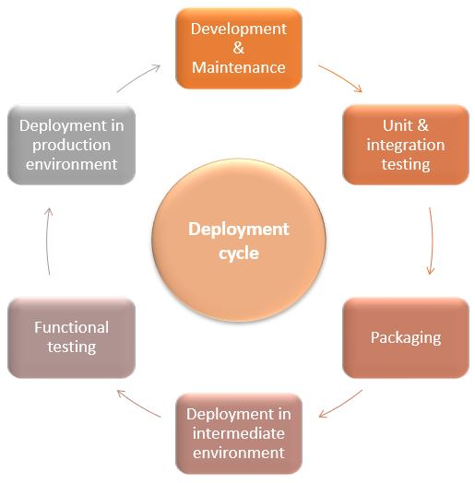

**Cycle de déploiement**

1. SOLUTION COST

Finally, the cost of the project calculated with the cocomo method is estimated at 40 million CFA francs.

# CONCLUSION

This project, which is part of the implementation of an automated personnel management platform for the Directorate General of Public Procurement, aims to respond to a problem faced by this Directorate General in the daily management of its personnel. This problem is based on the following questions:

How to make the personnel management system of the DGMP efficient?

How can the data from the DGMP's personnel management system be made reliable?

How to secure data on personnel?

How to produce reliable real-time statistics on personnel?

In order to address these issues, after analysing several solutions, we chose to develop a web application that would allow us to dematerialise all tasks related to personnel management. This application is made up of two parts: a front-end part designed to ensure the system's presentation logic and a back-end part implementing the business logic at work in the background. The frontend was developed using the React Framework, while the backend was developed using a microservice architecture with the Spring Boot Framework.

The implementation of this application will reduce the processing time of personnel files, secure and ensure the integrity of personnel data, and guarantee the production of reliable and timely statistics for easy decision making. Thus, the solution we propose will be able to respond effectively to the problem posed.

However, in order to ensure increased availability and more efficient operation of the system, we could envisage an evolution towards a deployment in the cloud.

# BIBLIOGRAPHIC REFERENCES

* How to Read Java de Laurentiu Spilca
* Spring Start Here de Laurentiu Spilca
* Spring Security in Action de Laurentiu Spilca

# WEBOGRAPHIE

<https://www.youtube.com/user/mohamedYoussfi/playlists>

<https://www.youtube.com/c/LaurentiuSpilca>

https://www.baeldung.com/

https://www.youtube.com/c/amigoscode

<https://www.youtube.com/c/JavaBrainsChannel/playlists>

https://www.youtube.com/c/DailyCodeBuffer

https://openclassrooms.com/

<https://www.alphorm.com/>

<https://www.youtube.com/channel/UCzuaB4F2znrMggxcwUuVhAw>

<https://www.youtube.com/channel/UC0FIKAE7xORm6Y91kWbg4cA>

<https://www.youtube.com/channel/UCj_iGliGCkLcHSZ8eqVNPDQ>

<https://www.youtube.com/channel/UCORuRdpN2QTCKnsuEaeK-kQ>

<https://www.youtube.com/channel/UCcHGNIgYpYOheI7oPWYd9Mw>

# TABLE OF CONTENTS